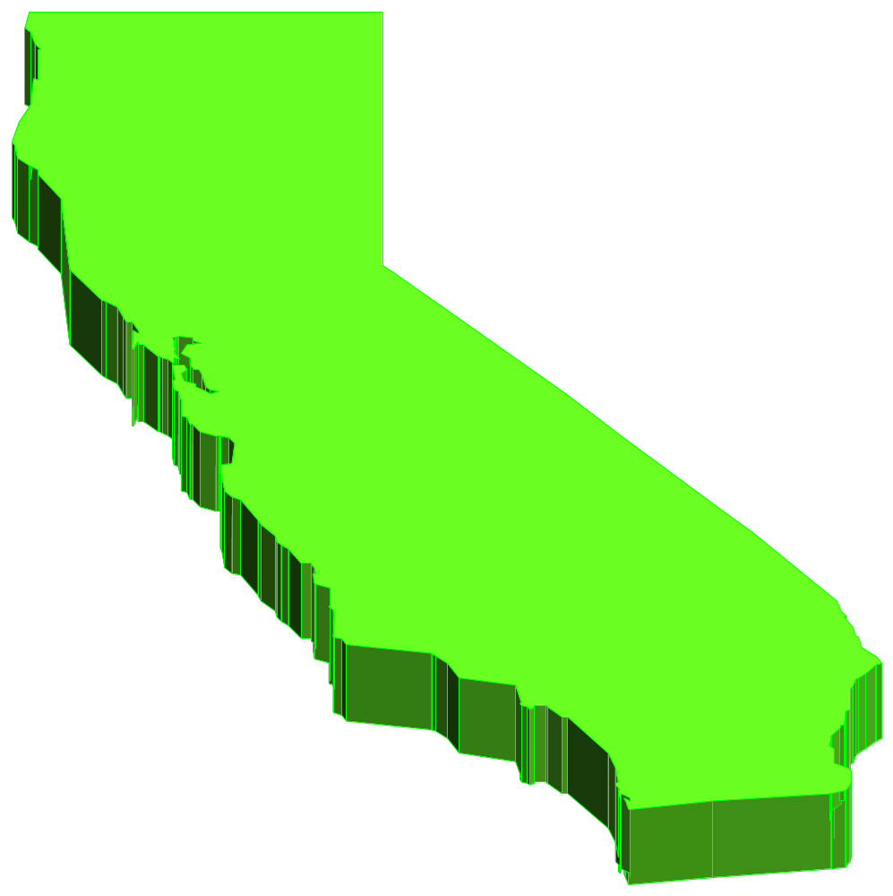
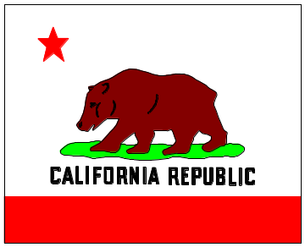
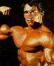
CAH-li-FOR-ni-a!!
I WANT TO PUMP
YOU UP!!!

